* **Test 1:**

Input: wzenwebuau

Output: eeuuwwabnz

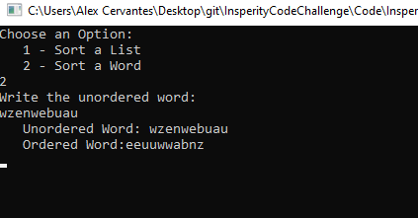

* **Test 2:**

Input: (Empty)

Output: (Empty)

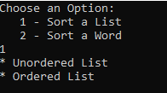

* **Test 3:**

Input: wzenwebuau,wqadfiodgs,qakmc,pzjim,xqycs,beoax,artrtnqxc

Output: eeuuwwabnz,ddafgioqsw,ackmq,ijmpz,cqsxy,abeox,rrrttacnqx

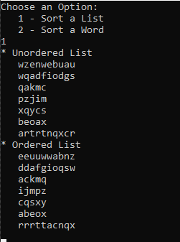

* **Test 4:**

Input: lflfkfhghskkkkksjfhjhfdhuuuuuuuuuuuuuufjjhsjdfjhaabajizlshusjjghsklkjhgfuuejsjkjhjgd

Output: uuuuuuuuuuuuuuuuujjjjjjjjjjjjjjhhhhhhhhhhhkkkkkkkkkffffffffsssssssggggllllaaadddbeiz

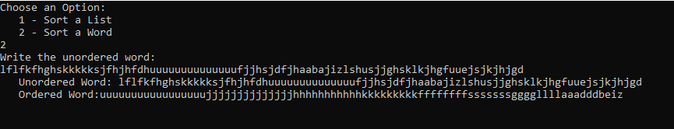

* **Test 5:**

Input: abcdefghijklmnopqrstuvwxyz

Output: abcdefghijklmnopqrstuvwxyz

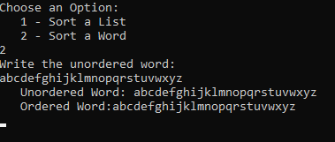

* **Test 6:**

Input: aaaaaaaaaaaaaaaaaaaaaaaaaaaaaaaaaaaaaaaaaaaaaaaa

Output: aaaaaaaaaaaaaaaaaaaaaaaaaaaaaaaaaaaaaaaaaaaaaaaa 